Remarks on

OnInterpret Website

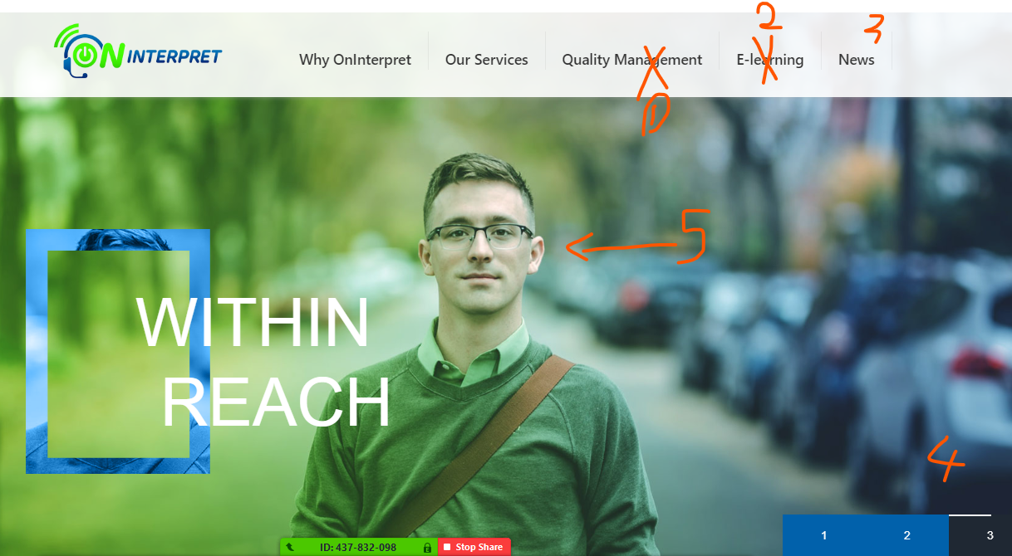

1- Make it: Quality Policy

2- Change to - Careers

3 - Change to – Blog

4- Make it Arrows

5- Change photo (Classroom for adults) but keep colors

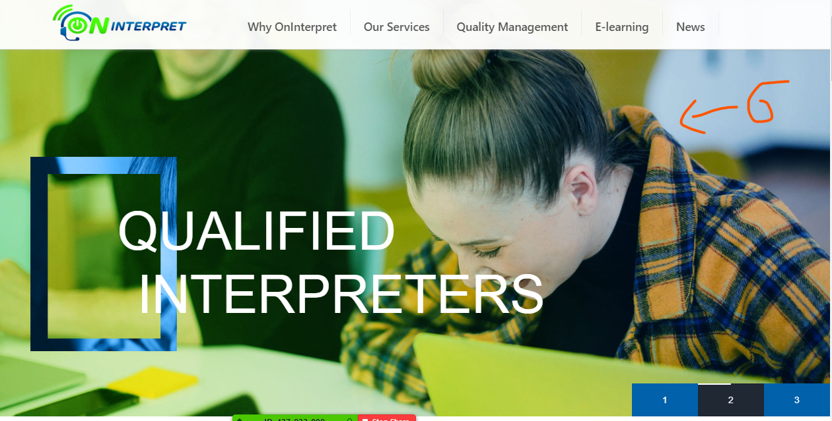

6- Change photo (Formal girl receiving calls & Smiling wearing veil if possible) but keep colors



7- Move "Why Us" to left and make it Large & add background (may be some professionals) stand alone

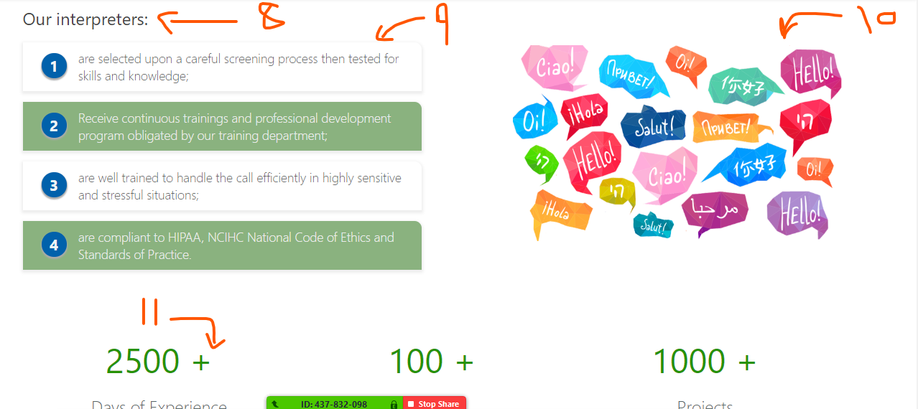

8- make it large and matching with "Our Services" in color & Size

9- make large and match green-background color with our logo

10 – minimize the photo a little

11- move the (+) to left and no spaces between signs and numbers & and make numbers counting as it be in [www.elingua.co](http://www.elingua.co)

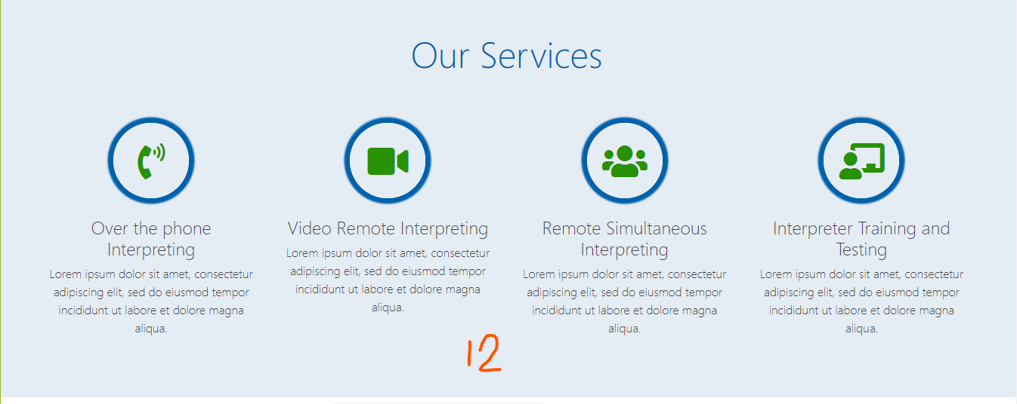

12 – update the content as provided.

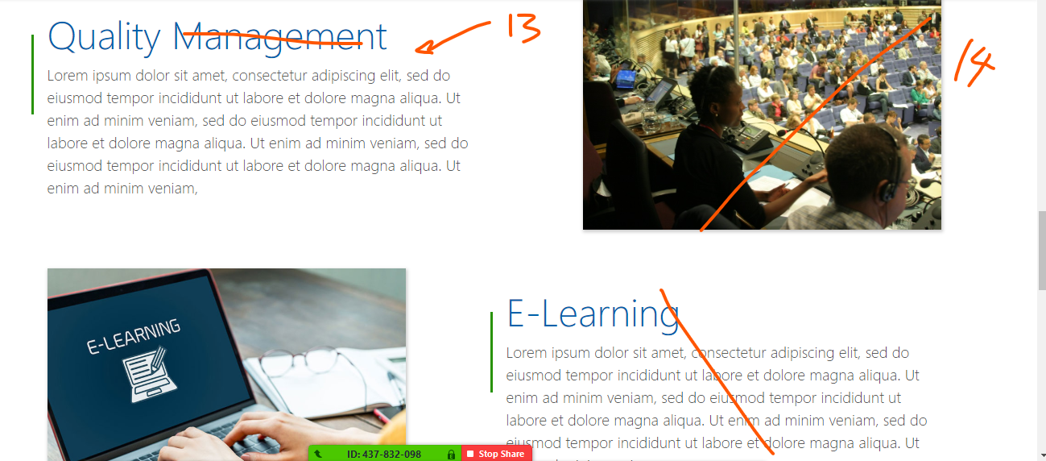

13- Change "Management" to "Policy" as in the Menu & update the content

14- change photo "checklist or alike" but the photo will be a background for the segment

15- Delete "e-learning"

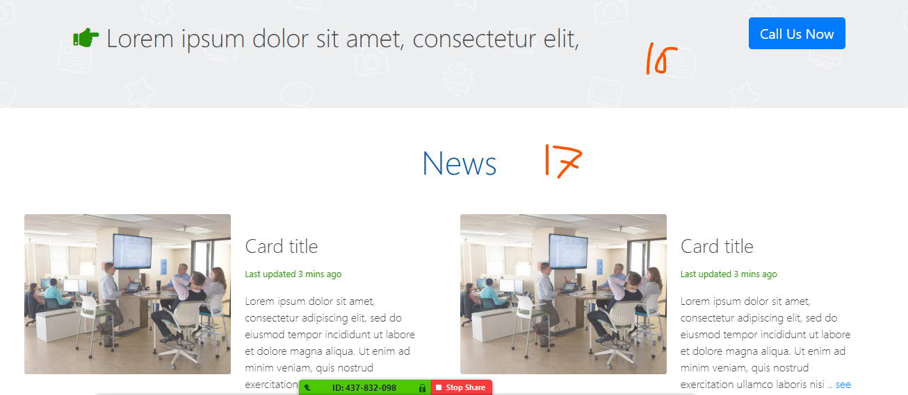

16- replace this part & e-learning with (industries) as provided in the updated content. **Industries will be in icons.**

17- change it with (Blog) to match the menus and make it as "our services" in colors and size.

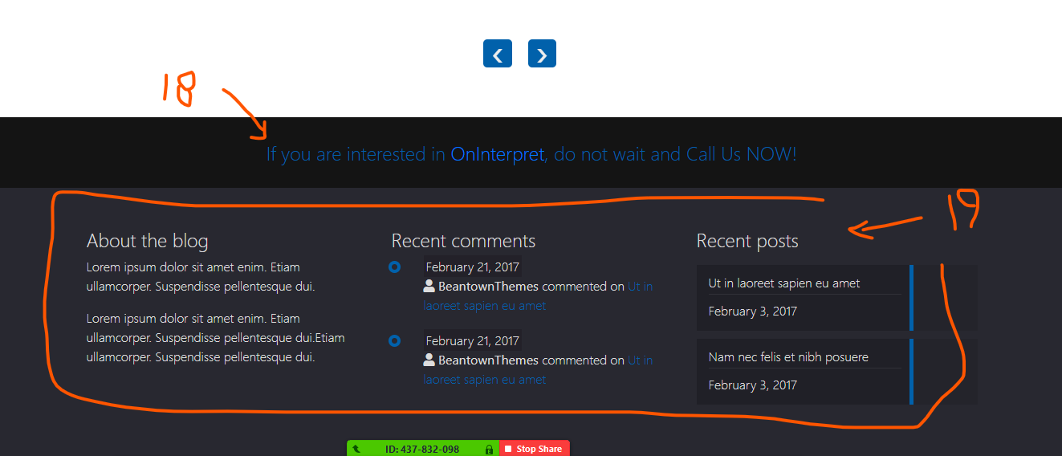

18- No need, you can delete it.

19- use same as in [www.elingua.co](http://www.elingua.co)

20- As for Careers and training registration plz [www.elingua.co](http://www.elingua.co) forms.